Monthly Performance Report – April 2025
Kestrel Ridge Wind Farm (75.6 MW)
David Chen · 09 May 2025 · KR-OPS-RPT-2025-04

1. Summary
Kestrel Ridge generated 16.0 GWh in April 2025, 3.6 % below the P50 budget of 16.6 GWh. Time-based availability was strong at 97.9 % (contract target 97.0 %). Mean hub-height wind speed of 7.8 m/s was close to the long-term mean (8.0 m/s). Compared with April 2024 (16.6 GWh), output was down 0.6 GWh.

2. Production and key figures
KPI | April 2025 | Budget / target | YTD 2025 | YTD budget
Net generation (GWh) | 16.0 | 16.6 | 80.3 | 84.7
Time-based availability | 97.9 % | 97.0 % | 97.4 % | 97.0 %
Capacity factor | 29.4 % | 30.5 % | 36.9 % | –
Mean wind speed at hub height (m/s) | 7.8 | 8.0 | – | –
Source: Kestrel Ridge SCADA, revenue meter at 132 kV point of connection. Budget = P50 (2024 post-construction yield assessment).
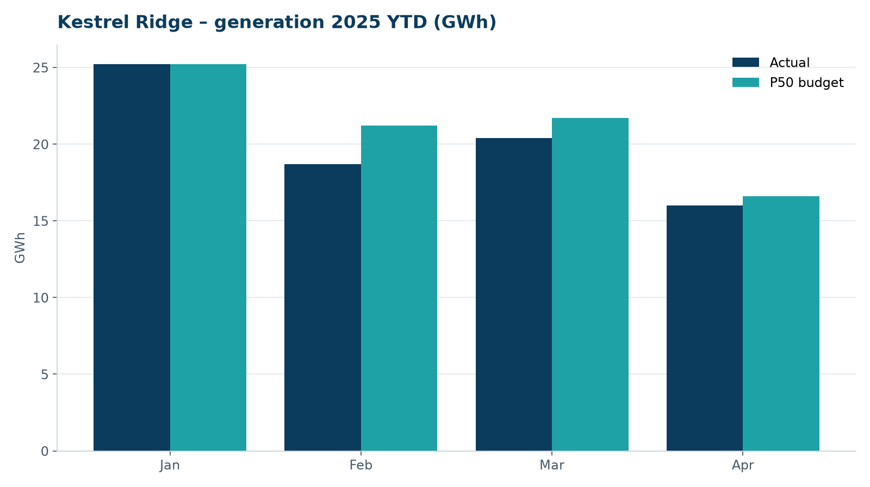
Monthly generation vs. P50 budget, 2025 year to date

3. Availability and downtime
Total turbine downtime attributable to the contractor amounted to 62 turbine-hours for the top events listed below. No grid or force majeure exclusions were claimed this month.
Turbine | Event | Downtime (h)
T-18 | pitch motor encoder fault on blade B | 21
T-09 | high-voltage transformer gas relay alarm (inspected, no fault found) | 11
T-12 | generator slip ring brush wear alarm | 10
T-11 | generator slip ring brush wear alarm | 10
T-09 | service lift fault – lift locked out, turbine stopped for rescue cover | 10
Top downtime events of the month (SCADA event log, reviewed with Highline Wind Services).

4. Maintenance
- 15 corrective work orders closed, 3 still open at month end.
- Substation monthly inspection completed; no abnormalities on the 33/132 kV transformer.

5. Health, safety and environment
Indicator | Month
Hours worked on site (Highline + Weyland) | 3,179
Lost time injuries | 0
First aid cases | 0
Near misses reported | 2
Safety observations | 5
Environmental incidents | 0

Toolbox talks this month covered lightning and storm procedures.

6. Outlook
Next month's focus: closing open corrective work orders and preparing the quarterly O&M review with Highline Wind Services.
Prepared by Sara Lindgren (Performance Analyst); reviewed by Ben Okoye (Site Manager) and David Chen (Asset Operations Manager).

